Name Date

Enrichment and Extension

1.3

Dart Subtraction Strategy

To play the Dart Subtraction Game, 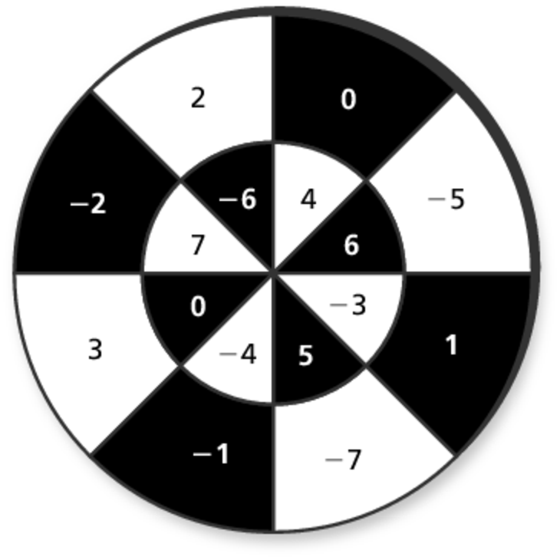you throw two darts and find your score by subtracting the value of the second dart from the value   
of the first dart. It is possible to land on   
the same value twice.

1. What is the highest possible score? What would have to be the value of the first dart? the second dart?

2. What is the lowest possible score? What would have to be the value of the first dart? the second dart?

3. List all the ways to get a score of 4. There are 11 different possibilities.

|  |  |  |  |  |  |  |  |  |  |  |  |
| --- | --- | --- | --- | --- | --- | --- | --- | --- | --- | --- | --- |
| First Dart |  |  |  |  |  |  |  |  |  |  |  |
| Second Dart |  |  |  |  |  |  |  |  |  |  |  |

4. List all the ways to get a score of 

5. How many ways could you get a score of 0? a score of 14? a score of 

6. If you are trying to get the *lowest* score, should you try to land on a positive   
or negative integer with your first dart? with your second dart? Explain your reasoning.

7. Play the game with a partner for ten rounds. Use paper punches as your darts.   
Hold your hand about 12 inches from the paper and drop the paper punches   
onto the target. Record your score after each round. Add up the score from   
each round to get your total score. Did you use any particular strategy?   
Describe.