Name Date

Enrichment and Extension

1.1

Reasoning with Integers

Assume  and  Determine whether the statement is *always, sometimes,* or *never* true.

1.  2.  3.  4. 

5.  6.  7.  8. 

Let *n* be an integer. Determine whether the possible values of *n* are *all integers, all positive integers, all negative integers, all positive integers and zero, all negative integers and zero,* or *none.*

9.  10.  11.  12. 

13.  14.  15.  16. 

17.  18.  19.  20. 

21.  22.  23.  24. 

25.  26.  27.  28. 

29.  30.  31.  32. 

33.  34.  35.  36. 

For each exercise number, use your 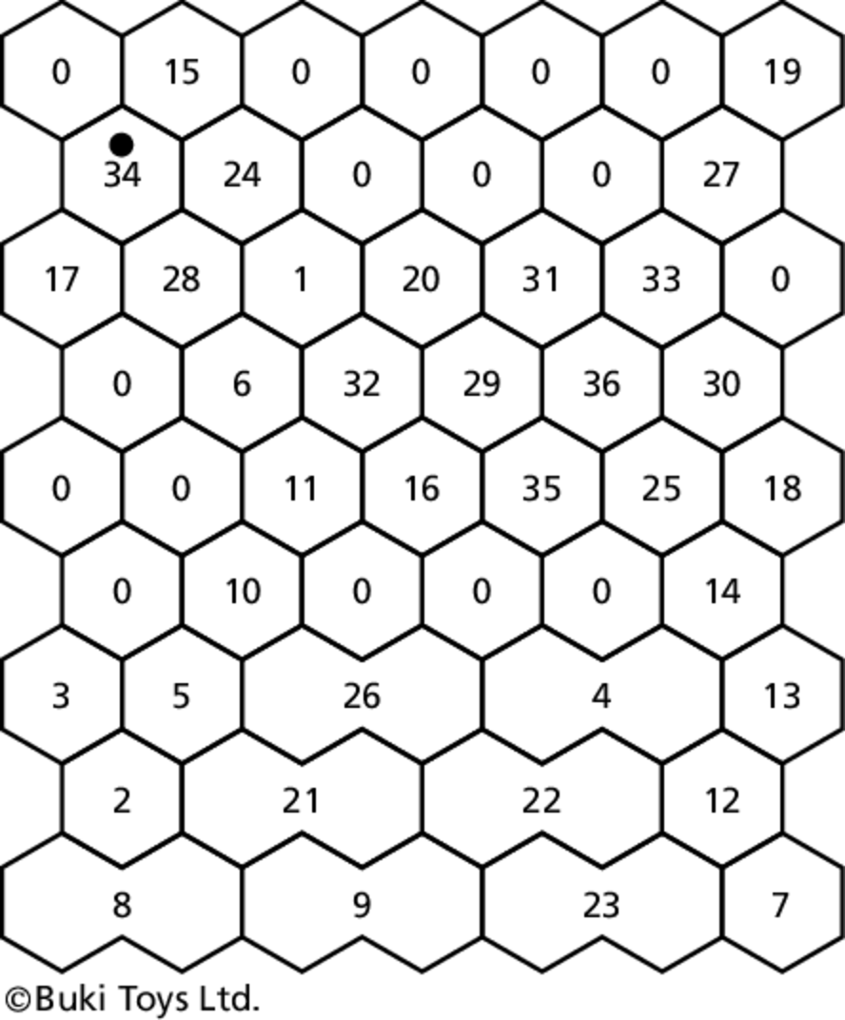  
answers and the key below to color   
the cell. Do not color the cells that   
have a zero in them.

Always  Orange

Sometimes  Green

Never  Brown

All Integers  Brown

All Positive Integers  Brown

All Negative Integers  Green

All Positive Integers and Zero  Green

All Negative Integers and Zero  Brown

None  Brown